CHAPTER 1
INTRODUCTION
  - OVERVIEW
An AI powered eye for visually challenged people is an assistive technology that uses artificial intelligence computer vision and audio feedback to help individuals with visual impairments perceive and interactive with their surroundings. By integrating a camera to capture real world images and AI algorithms to interpret them, the system can identify objects, read text, recognize faces, and describe scenes in real time. The processed information is then conveyed to the user through spoken audio or vibrations, enabling safer navigation and greater independence in daily life. This innovation aims to act as an intelligent companion that enhances accessibility, autonomy and confidence for visually impaired individuals.

INTRODUCTION

An AI powered eye for visually challenged people is an assistive technology that uses artificial intelligence computer vision and audio feedback to help individuals with visual impairments perceive and interactive with their surroundings. By integrating a camera to capture real world images and AI algorithms to interpret them, the system can identify objects, read text, recognize faces, and describe scenes in real time. The processed information is then conveyed to the user through spoken audio or vibrations, enabling safer navigation and greater independence in daily life. This innovation aims to act as an intelligent companion that enhances accessibility, autonomy and confidence for visually impaired individuals.
In recent years, advancements in Artificial Intelligence (AI) and computer vision have opened the door to a new generation of assistive technologies designed to support individuals with disabilities. Among those who benefit most from these innovations are visually impaired individuals, who often face daily challenges in navigating unfamiliar spaces, recognizing people, reading written information, and understanding their surroundings. While traditional mobility aids like walking canes and guide dogs provide essential support, they still fall short in offering complete, real-time awareness of the environment. This project, titled “Artificial Intelligence Powered Eye for Visually Challenged People,” aims to bridge that gap by creating a smart, portable, AI driven solution that functions as an assistive “eye,” helping users experience the world with greater clarity and confidence.

The core idea behind the system is to develop a wearable or handheld device that captures real-time video through a camera and processes it using machine learning algorithms to identify objects, faces, and text. This visual information is then converted into clear audio output and delivered to the user through a speaker or headphones, allowing them to “hear” what they cannot see. The system uses advanced tools such as Mobile Net SSD for object detection, Tesseract OCR for reading text, and facial recognition libraries to identify familiar individuals. Python serves as the main programming language, supported by OpenCV for video processing and for Pyttsx3 real time text to speech conversion. This combination of software tools ensures that the system can operate smoothly even in dynamic, real world environments. The modular nature of the code also makes it easy to update or expand the system with new features in the future.
This AI powered system supports a wide range of real world applications. It can help users recognize friends or family members through facial recognition, identify everyday objects like chairs, doors, or vehicles, and read signs, notices, or product labels using OCR. The real time audio feedback allows users to make informed decisions without relying on others, promoting autonomy and self assurance in daily activities.
The design is also highly modular and scalable, allowing for future enhancements. Features such as voice- controlled commands, GPS based navigation, ultrasonic obstacle detection, or cloud connectivity for more advanced AI processing can be added as needed. The system can also be expanded to support multilingual text recognition and speech output, making it more inclusive for users in diverse linguistic environments.
In summary, this project brings together modern AI technologies to support a meaningful cause helping visually challenged individuals lead more independent, dignified, and empowered lives. It demonstrates how low cost, open source tools can be combined to create impactful assistive devices that enhance accessibility and human capability. The Artificial Intelligence Powered Eye is not just a technological innovation; it represents a step forward in inclusive design and social responsibility.
Looking ahead, future improvements can focus on making the system even more intelligent, interactive, and adaptable to real-world conditions. Emotion recognition could help users understand the expressions and intentions of people around them, while edge AI optimization would ensure faster processing on lightweight hardware like the Raspberry Pi 4. Cloud integration could enable regular updates, multilingual translation, and personalized user data storage. The true value of this project lies in the sense of independence, dignity, and emotional comfort it brings to visually impaired individuals.

  - CHALLENGES
The development of the AI Smart Glasses for Visual Assistance presented several technical and practical challenges. Implementing real time face recognition, text recognition, and object detection on an embedded platform such as the Raspberry Pi 4 is constrained by limited processing power and memory, requiring careful optimization to maintain acceptable frame rates. Variations in lighting conditions, motion blur, and camera angle significantly affect the accuracy of computer vision algorithms, leading to occasional misclassification or missed detections. The face recognition module based on OpenCV can be impacted by changes in facial appearance, expressions, or occlusions, while the text recognition module using PyTesseract struggles with complex backgrounds, low resolution text, and handwritten content. Although the MobileNetSSD provides efficient real time performance, it involves a trade-off between detection speed and accuracy, especially for small or overlapping objects. Managing simultaneous audio outputs from multiple modules without overwhelming the user is another challenge, requiring effective priority and queue handling.
- RealTime Performance Constraints
Achieving smooth real-time processing (10–15 FPS) while running multiple AI modules in parallel requires careful optimization of image resolution, model size, and processing pipelines.
- Lighting Variations and Image Quality
Face recognition and OCR accuracy are highly dependent on lighting conditions. Poor illumination, shadows, glare, or motion blur can reduce detection accuracy and lead to incorrect or missed announcements.
- Accuracy of Face Recognition
The face recognition system using OpenCV may produce false positives or fail to recognize faces if there are changes in facial appearance, expressions, accessories (glasses, masks), or aging.
- Text Recognition Limitations
OCR performance using PyTesseract is sensitive to font style, text size, orientation, background complexity, and handwritten text, making reliable text extraction difficult in real world environments.
- Object Detection Trade-off Between Speed and Accuracy
While MobileNetSSD is optimized for speed, it may struggle to detect very small, overlapping, or uncommon objects, especially in cluttered scenes.

1.4 PROBLEM STATEMENT
Visually impaired individuals often struggle to understand and interact with their surroundings, especially in situations that require quick decisions or awareness of subtle details. Simple tasks like identifying objects, recognizing familiar faces, or reading signs can become major challenges without proper support. Traditional aids such as white canes and guide dogs provide essential mobility assistance, but they do not offer complete information about the environment, leaving users with gaps in awareness that can affect safety and independence.
With the rapid growth of Artificial Intelligence and computer vision technologies, there is a clear opportunity to create smarter, more intuitive tools that can interpret visual information in real time. However, many existing solutions are either too expensive, too complex, or not designed with the everyday needs of visually impaired individuals in mind. This creates a significant gap between what technology can offer and what users actually receive in terms of practical, accessible support. There is a need for a system that is not only intelligent but also affordable, portable, and easy to use in daily life.
This project addresses that gap by aiming to develop an AI powered assistive device that can act as an artificial “eye,” helping users understand their surroundings through audio feedback. By converting visual information into meaningful speech, the system empowers visually impaired individuals to navigate spaces more confidently and independently. The goal is to provide a solution that enhances safety, reduces dependence on others, and supports a more dignified and self reliant lifestyle for those who face visual challenges every day.
  - PROPOSED SOLUTION
The proposed solution is an AI Powered eye that assists visually impaired users by converting visual information into real time audio feedback using an embedded computing platform. The system is built around the Raspberry Pi 4, which processes continuous video input captured through a mounted camera using computer vision and deep learning techniques. Face recognition is implemented using OpenCV to identify known individuals and announce their names, while text recognition is achieved through PyTesseract to read printed text from signs, labels, and documents aloud. For environmental awareness, object detection is performed using the MobileNetSSD trained on the COCO dataset, enabling real time identification of common objects with spatial cues. All modules are integrated into a unified processing framework with priority-based audio management to avoid information overload, and the system is powered by a portable power bank with audio output delivered through earphones, providing a cost effective, portable, and practical assistive solution for visually impaired individuals.

1.6 OBJECTIVE
The objectives of this project are to design and implement AI-powered smart glasses using a Raspberry Pi 4 and camera module, and to develop a face recognition system using OpenCV that can identify individuals and announce their names through audio output. The system also aims to perform text detection and reading by integrating Tesseract OCR with text-to-speech conversion. Additionally, an object detection module using Mobile Net SSD will be created to enhance environmental awareness. All AI functionalities will be integrated into a unified wearable device that ensures portability through power bank operation and audio delivery via earphones. The project further focuses on optimizing processing for real-time performance on Raspberry Pi hardware and developing an accessible user interface suitable for visually impaired users.

1.7 MOTIVATION

The motivation for developing this AI-powered Virtual Eye system is to address the daily challenges faced by visually impaired individuals in navigating their surroundings, identifying objects, and accessing printed information independently. Visual impairment significantly limits mobility and awareness, and although traditional aids such as white canes offer basic support, they lack the ability to interpret complex environments or provide contextual information. With recent advancements in Artificial Intelligence, computer vision, and embedded platforms like Raspberry Pi, it has become feasible to design an intelligent, portable, and cost-effective assistive device that can capture real time visual data, analyze it using AI models, and convey meaningful information through audio output. This project is driven by the need to enhance personal safety, confidence, and independence of visually challenged users by enabling features such as object detection, obstacle awareness, and text recognition, while also demonstrating how modern technology can be practically applied for social welfare and inclusive innovation.

CHAPTER 2
LITERATURE SURVEY
[1]. Bharath Kumar T, Sree Lakshmi, M.
“Smart Glasses for the Visually Impaired using AI”. 2019 (IEEE)
This study proposed a wearable smart glasses system that integrates sensors, a camera, and audio output to assist visually impaired users. The system used basic object detection and ultrasonic sensors to warn users of nearby obstacles. While the concept was helpful, its object recognition capability was limited, highlighting the need for more advanced AI techniques for better results. This research demonstrated the potential of combining simple sensors with wearable technology.
[2]. Al-Mamun M. A, Rahman M. M.
“An Intelligent Assistant for Visually Impaired People”. 2019 (IEEE)
This paper presented a vision-based system for blind users using Raspberry Pi, OpenCV, and speech feedback. The device could recognize common objects and provide audio descriptions. The study emphasized the importance of real time feedback and the potential for deep learning models to improve recognition accuracy and user experience. It also highlighted how low cost hardware like Raspberry Pi can still deliver meaningful assistance when paired with efficient algorithms.

[3]. Kumar S and Sahoa G.

“AI Based Wearable Device for Visually Impaired using YOLO and Text to Speech Conversion”. 2021 (IEEE)
This research implemented a wearable system using the YOLO (You Only Look Once) object detection algorithm and text to speech technology to describe the surroundings. It demonstrated the effectiveness of deep learning in detecting multiple objects in real time and delivering fast, accurate auditory feedback. The system achieved promising results in controlled environments but highlighted challenges.
[4]. Isha S. Dubey, Jyostna S. Verma.
“An Assistive System for Visually Impaired using Raspberry PI”. 2019 (IEEE)
The paper briefs about a different combination of a reading machine (OCR), virtual assistant and domotics system using Raspberry-Pi which will be a combination of a great system. This is a helpful aid for visually impaired people and people with disabilities. OCR stands for optical character recognition where it recognizes the present text and converts them into audio speech using pre and post processing with gTTS (Google Text to Speech).

[5]. L. Manirajee S.Q.H, Shariff S.M.M. Rashid.

“Assistive technology for visually impaired individuals”. 2024 (IEEE)
The systematic literature review by L. Manirajee, S. Q. H. Shariff, and S. M. M. Rashid (2024) provides a comprehensive overview of modern assistive technologies designed for visually impaired individuals. The authors examine a wide range of existing solutions including wearable devices, sensor- based navigation systems, mobile applications, and AI Powered vision aids and evaluate their effectiveness, usability, and limitations. The survey highlights current research trends, identifies gaps such as cost, accessibility, and real world performance challenges, and suggests future directions for developing more user-friendly, reliable, and affordable assistive technologies.

CHAPTER 3

DESIGN AND METHODOLOGY

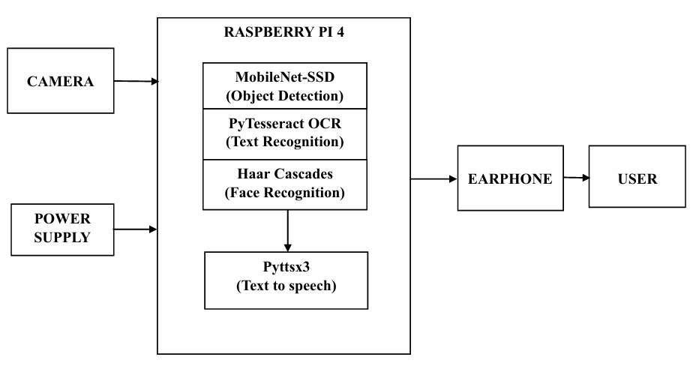
3.1 BLOCK DIAGRAM
Figure 3.1 Block Diagram

The block diagram shows how the entire assistive device works by following a clear flow of information from input to output. It begins with the camera, which continuously captures the user’s surroundings and sends the visual data to the Raspberry Pi 4 for processing. Inside the Raspberry Pi 4, different AI modules such as object detection, text recognition OCR, and face recognition analyze the incoming images to identify what is present in the environment. Once the system interprets the scene, the processed results are passed to the audio output unit, which converts the information into spoken feedback that the user can easily understand. A power supply supports all components, ensuring smooth and uninterrupted operation. Together, these blocks form a simple but effective pipeline that helps visually impaired users receive real-time awareness of their surroundings.

The project focuses on creating an AI based assistive device that helps visually impaired individuals understand their surroundings more easily and independently. By using a camera and a Raspberry Pi 4, the system captures real-time visuals and processes them instantly to provide meaningful audio feedback. This approach allows users to receive information about objects, text, and people around them without needing to rely on others. The main intention behind the design is to offer a practical, affordable, and portable solution that can genuinely support users in their daily routines. With advancements in computer vision and lightweight AI models, it becomes possible to build a device that feels both intelligent and accessible.
The design of the system revolves around the Raspberry Pi 4, which serves as the central processing unit. A camera module continuously captures the environment, sending the visual data to the Pi for analysis. Inside the device, different AI modules work together: object detection identifies items in front of the user, OCR reads printed or digital text, and face recognition helps detect familiar individuals. These modules operate in real time, ensuring that the user receives immediate feedback. The processed information is then converted into speech and delivered through a speaker or earphones, making the interaction simple and intuitive.
The block diagram of the system represents this flow clearly. It begins with the camera at the input stage, followed by the Raspberry Pi 4 at the centre, where all processing takes place. The Pi branches into different AI modules that handle object detection, text recognition, and face recognition separately. Once the analysis is complete, the results move to the audio output unit, which communicates the information to the user. A power supply supports the entire system, ensuring stable operation during daily use. This structure highlights how each component works together to create a smooth and reliable assistive experience.
The physical design of the device prioritizes comfort, portability, and ease of use. The camera can be mounted on glasses or a small chest clip, allowing the user to move freely without feeling restricted. Lightweight materials and compact enclosures help reduce bulk, making the device suitable for long term wear. The wiring is kept minimal, and the components are arranged in a way that avoids discomfort or distraction. The goal is to create a device that blends naturally into the user’s lifestyle rather than feeling like a heavy or complicated gadget.

3.2 FLOW CHART
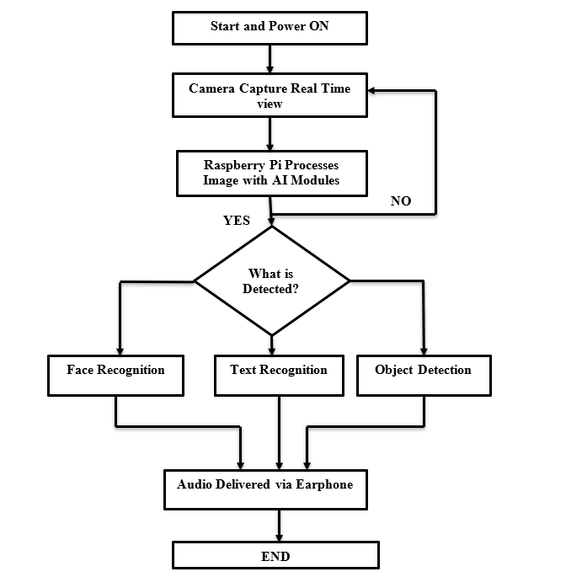

Fig.3.2 Flow chart

3.3 CIRCUIT DIAGRAM
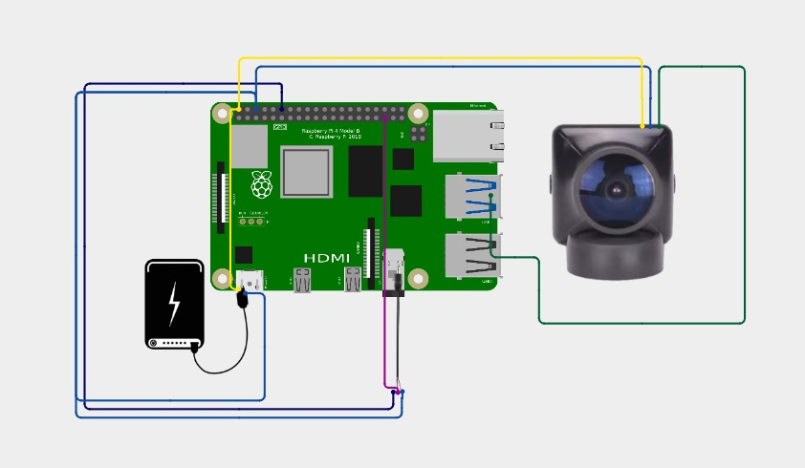

Fig 3.3. Circuit Diagram

The central controller is the Raspberry Pi 4, which coordinates all input, processing, and output operations. A USB webcam is connected to one of the Raspberry Pi’s USB ports to capture real-time image of the user’s surroundings for face recognition, text recognition, and object detection. A portable power bank supplies 5V power to the Raspberry Pi through the USB C power port, ensuring mobility and uninterrupted operation. Earphones are connected via the 3.5 mm audio jack to deliver audio feedback generated by the text to speech module. The Raspberry Pi processes the camera feed using AI algorithms and converts the detected visual information into spoken output, making the system compact, portable, and suitable for wearable assistive applications.

3.4 METHODOLOGY

3.4.1 SYSTEM ARCHITECTURE
The project is built around a Raspberry Pi 4 equipped with a 32 GB SD card for storage, providing ample space for the operating system, libraries, and captured data. It captures visual information using a Raspberry Pi Camera Module V2, which delivers high‑resolution images suitable for real‑time analysis. The processing core runs Python scripts that leverage OpenCV for computer‑vision tasks, PyTesseract for optical‑character recognition, and a MobileNet‑SSD model to perform efficient object detection. Audio feedback is delivered either through the standard 3.5 mm earphone jack or via Bluetooth, allowing the user to receive alerts or spoken instructions without needing external speakers. Power is supplied by a portable power bank with a capacity of 10,000–20,000 mAh, ensuring the device can operate for several hours on a single charge while remaining lightweight and easy to carry.

3.4.2 FACE RECOGNITION MODULE
The system begins by creating a face database, where it captures a series of high‑resolution images of each known individual and stores them securely on the Raspberry Pi’s SD card for later reference. Once the database is populated, the training phase kicks in: the software loads the collected face images and uses OpenCV’s built‑in face recognizer the classic Eigenfaces method to generate a robust facial model that can distinguish one person from another. After training, the device enters real‑time detection mode, continuously scanning the live video feed from the Raspberry Pi Camera Module V2 to locate any faces that appear in the frame. When a face is detected, the system immediately runs the recognition routine, comparing the extracted facial features against the stored models in the database.

3.4.3 OBJECT DETECTION MODULE

The Object Detection Module functions as an environmental awareness system by implementing pre trained MobileNetSSD model trained on the COCO dataset, enabling efficient and real time object detection on resource-constrained devices. Live video frames captured from the camera are continuously processed through the neural network to identify and classify more than 80 common object categories such as people, vehicles, furniture, and everyday items. Along with object recognition, the system estimates spatial information like object position within the frame and approximate distance using bounding box size and relative placement, helping users understand their surroundings more intuitively. The detected information is then converted into concise and meaningful audio descriptions through a text-to-speech system.

3.4.4 TEXT RECOGNITION MODULE

The system first employs OpenCV to locate and isolate text regions within each captured image, using contour analysis and morphological operations to highlight areas that contain characters while suppressing background clutter. Once the relevant regions are identified, PyTesseract is invoked to perform optical character recognition, converting the visual patterns into machine‑readable strings that preserve the original wording as accurately as possible. The raw OCR output is then passed through a text‑processing stage where stray symbols, duplicate spaces, and recognition errors are filtered out, and the extracted sentences are formatted for readability capitalizing proper nouns, inserting appropriate punctuation, and grouping related
fragments together.

3.4.5 SYSTEM INTEGRATION

The Raspberry Pi Camera Module V2 continuously captures a live video stream, feeding each frame into a high throughput processing pipeline where the three AI modules face recognition, text detection, and object detection run in parallel on separate threads so that facial identities, printed words, and environmental cues are analyzed simultaneously. A priority management routine evaluates the relevance of each inference in real time, applying decision logic that ranks announcements and ensures that only the most important information is spoken first. An audio queue manager buffers the synthesized speech fragments, preventing multiple outputs from overlapping and guaranteeing clear, sequential playback through either the 3.5 mm earphone jack or Bluetooth audio. Finally, a lightweight user interface accessible via a connected touchscreen or a simple command line menu lets the operator select operating modes, adjust confidence thresholds, and start or stop the system with just a few taps, providing intuitive control.

3.4.6 ALGORITHM

BEGIN

Initialize Raspberry Pi system

Load camera module

Load face recognition model

Load OCR engine

Load object detection model

Initialize text-to-speech engine

Initialize audio queue

WHILE system is powered ON

DO Capture frame from camera

Preprocess frame (resize, convert to grayscale)

// Face Recognition Module

Detect faces in frame

IF face detected THEN

Extract facial features

Compare with trained face database

IF confidence > threshold THEN

Generate audio: "Person name detected"

Add audio to queue

END IF

END IF

// Text Recognition Module

Detect text regions in frame

IF text region detected

THEN Extract text using OCR

Clean and format extracted text

IF text is valid THEN

Convert text to speech

Add audio to queue

END IF

END IF

// Object Detection Module

Detect objects in frame

FOR each detected object DO

IF object confidence > threshold THEN

Determine object position (left / center / right)

Generate audio description

Add audio to queue

END IF

END FOR

// Audio Management

IF audio queue is not empty THEN

Play next audio message

END IF

END WHILE

Release camera resources

Stop audio system

Shutdown Raspberry Pi safely

END

AI ALGORITHMS USED:

Face Recognition module : Local Binary Pattern Histogram (LBPH) Algorithm, implemented through OpenCV.

Face Detection : Haar Cascade Algorithm.

Text Recognition : Tesseract OCR Algorithm.

Object Detection : SSD MobileNet Algorithm.

Text Recognition : Text to Speech (TTS).

CHAPTER 4

HARDWARE AND SOFTWARE REQUIREMENTS

HARDWARE REQUIREMENTS

    - Raspberry Pi 4
    - 32GB Micro SD Card (Class 10 or higher)
    - Raspberry Pi Camera Module V2
    - Camera Ribbon Cable (appropriate length for glasses mounting)
    - Portable Power Bank (10,000-20,000 mAh with 5V/3A output)
    - USB C Cable for Raspberry Pi power
    - Earphones (wired 3.5mm)

SOFTWARE REQUIREMENTS
- Raspberry Pi OS
- Python 3.7 or higher
- OpenCV 4.x with Python bindings
- PyTesseract OCR engine
- Tesseract OCR binaries
- MobileNetSSD model files
- Text to Speech libraries (gTTS, Pyttsx3, or espeak)
- NumPy and SciPy for numerical computations
- Picamera2 library for camera control
- Multiprocessing libraries for parallel execution

4.1.1 RASPBERRY PI 4
Raspberry Pi 4 plays a vital role in the AI-powered eye project for visually challenged people, acting as the main processing unit that integrates hardware components and executes intelligent functions. It is a compact, affordable, and powerful microcomputer capable of handling complex image processing and deep learning tasks essential for object detection, facial recognition, and text reading. The device efficiently runs AI models such as OpenCV and TensorFlow Lite, which help in analyzing the surroundings and converting visual information into audio output for the user.
Its multiple connectivity options, including USB, HDMI, Bluetooth, and Wi-Fi, make it ideal for connecting peripherals like cameras, speakers, and sensors. The quad-core processor and sufficient RAM ensure smooth real-time performance, even when dealing with high-resolution image data. Raspberry Pi 4 also supports various programming languages, making it flexible for implementing customized algorithms and integrating speech and vision modules.
By using Raspberry Pi 4, the project achieves a balance between cost, portability, and processing efficiency. It enables the system to function independently without relying on cloud computing, ensuring faster response times and offline usability, which are crucial for the safety and convenience of visually challenged individuals in daily life.
Raspberry Pi 4 is the most advanced model in the Raspberry Pi series, designed to perform tasks similar to a desktop computer while being compact and energy-efficient. It features a Broadcom BCM2711 quad- core Cortex-A72 processor with clock speeds up to 1.5 GHz, available in different RAM variants (2GB, 4GB, and 8GB), which provides ample processing power for AI and machine learning applications. In the AI- powered eye project.
The Raspberry Pi 4 has a 40-pin GPIO (General Purpose Input/Output) header that allows it to interface with various sensors, modules, and external devices. These pins are used for digital input and output, power supply, communication protocols, and other control functions. The GPIO layout follows a standard configuration that is backward compatible with previous Raspberry Pi models, making it easy to connect accessories and expansion boards.
Out of the 40 pins, 26 are GPIO pins, and the remaining pins are assigned for power, ground, and specific communication interfaces. The power pins include 5V (pins 2 and 4) and
3.3V (pin 1 and 17) which supply voltage to external components. Ground pins (pins 6, 9, 14, 20, 25, 30, 34, and 39) complete the electrical circuit. The communication interface pins include I2C (pins 3 and 5) for sensors, SPI (pins 19, 21, 23, 24, and 26) for high-speed peripherals, and UART (pins 8 and 10) for serial communication with other devices. These GPIO pins can be programmed

using Python or C to control external components such as ultrasonic sensors, cameras, buzzers, or motors. Each pin can be configured as input or output depending on the project requirements. For the AI-powered eye project, specific pins are used to connect the camera module, audio output, and vibration or ultrasonic sensors that help detect objects and obstacles in the user's path.

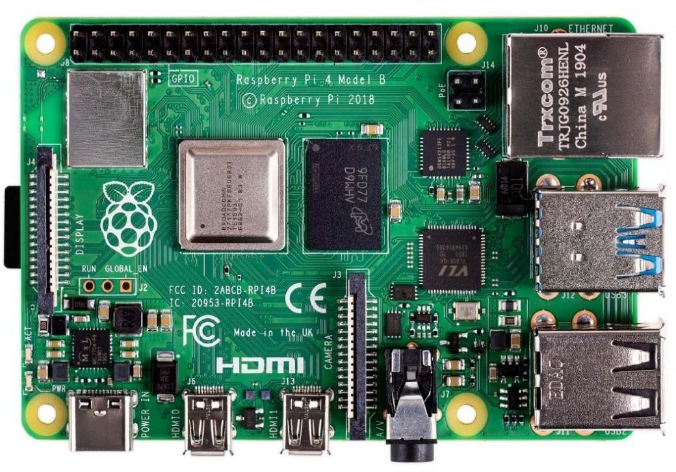
Fig 4.1.1 Raspberry Pi 4

4.1.2 PI CAMERA/USB CAMERA

In the AI-powered eye project for visually challenged people, the camera is one of the most crucial components, as it serves as the “eye” of the system by capturing the surrounding environment in real time. Both Pi Camera and USB Camera can be used with Raspberry Pi 4, depending on the project requirements and desired image quality.
The Raspberry Pi Camera Module is a compact and high-quality camera specifically designed for the Raspberry Pi. It connects directly to the CSI (Camera Serial Interface) port on the Raspberry Pi board, ensuring faster data transfer and lower latency compared to USB cameras.

The latest Pi Camera modules, such as the Camera Module 2 or HQ Camera, support resolutions up to 8 or 12 megapixels and offer excellent image clarity under various lighting conditions. These cameras are ideal for object detection, face recognition, and text reading tasks as they provide stable frame rates and high-definition video output suitable for real-time AI processing.
Alternatively, a USB Camera (webcam) can also be used if the Pi Camera is unavailable. It connects through one of the Raspberry Pi’s USB ports and is compatible with most OpenCV based computer vision applications. USB cameras are easy to install and support plug and play functionality, making them a good option for quick prototyping or testing. However, they may consume slightly more power and have higher latency than the Pi Camera.

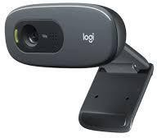

Fig 4.1.2 USB Camera

4.1.3 EARPHONE
In the AI-powered eye project for visually challenged people, the earphone serves as the main output device, providing real-time audio feedback to the user. Since the project focuses on assisting individuals who cannot rely on vision, sound output is crucial for conveying information such as object detection results, text- to-speech conversion, or environmental alerts. The system converts processed visual data into speech or sound signals, enabling the user to understand their surroundings through hearing.
Earphones or Bluetooth headsets are often preferred. They provide clear and private audio feedback directly to the user without disturbing others. Earphones can connect via the Raspberry Pi’s 3.5mm audio jack, Bluetooth, or USB sound card if required. Bluetooth earphones are especially convenient because they are wireless, allowing the user to move freely without tangled cables.

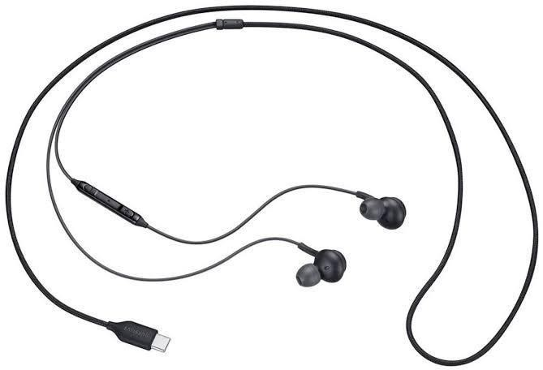

Fig 4.1.3 Earphone

4.1.4 PORTABLE POWER BANK

A portable power bank is an essential component in an AI-powered eye project because it ensures continuous energy supply to sensors, cameras, and processing units. Since such projects often involve wearable or mobile devices designed for vision assistance or surveillance, a stable and portable power source is necessary to maintain functionality without relying on fixed electrical connections. This makes the system more practical and user-friendly in real-world scenarios.
By providing mobility and convenience, the power bank allows the AI-powered eye device to operate in diverse environments, whether indoors or outdoors. It supports uninterrupted data collection and processing, which is crucial for applications such as accessibility tools for the visually impaired, smart monitoring systems, or healthcare-related vision aids. The portability of the power bank also makes the project adaptable for long-term use and field testing.
In addition to convenience, the power bank acts as a backup to prevent sudden power loss, thereby increasing the reliability of the system. Its rechargeable nature ensures sustainability, while its compatibility with different hardware modules makes it scalable for future upgrades. Overall, the portable power bank enhances the efficiency, usability, and resilience of the AI-powered eye project, making it a vital element for successful implementation.

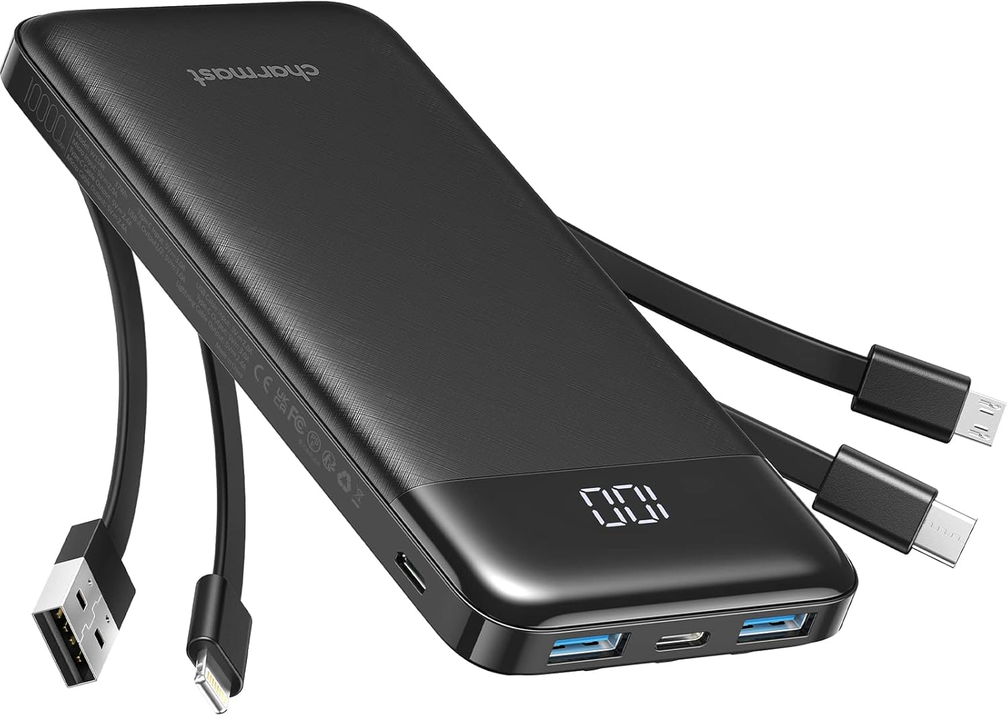
Fig 4.1.4 Portable power bank

4.2 SOFTWARE DESCRIPTION
Raspbian is the official operating system (OS) for the Raspberry Pi single-board computers (SBCs). Developed and maintained by the Raspberry Pi Foundation, Raspbian is based on the Debian Linux distribution and optimized for the ARM architecture used in Raspberry Pi hardware. With its user-friendly interface, extensive software library, and robust performance, Raspbian serves as a versatile platform for various applications, including education, prototyping, DIY projects, home automation, and more. In this comprehensive software description, we will delve into the features, components, customization options, and real-world applications of Raspbian OS for Raspberry Pi.

4.2.1 Introduction to Raspberry Pi OS:
Raspbian OS is designed to provide a stable, reliable, and user-friendly computing environment for Raspberry Pi users, whether they are beginners or experienced enthusiasts. It offers a familiar Linux-based operating system experience while leveraging the unique capabilities of Raspberry Pi hardware, such as GPIO (General Purpose Input/Output) pins, camera interfaces, and hardware acceleration for multimedia playback. Raspbian is distributed as a free and open- source software package, allowing users to download, install, and customize it according to their specific needs and preferences.
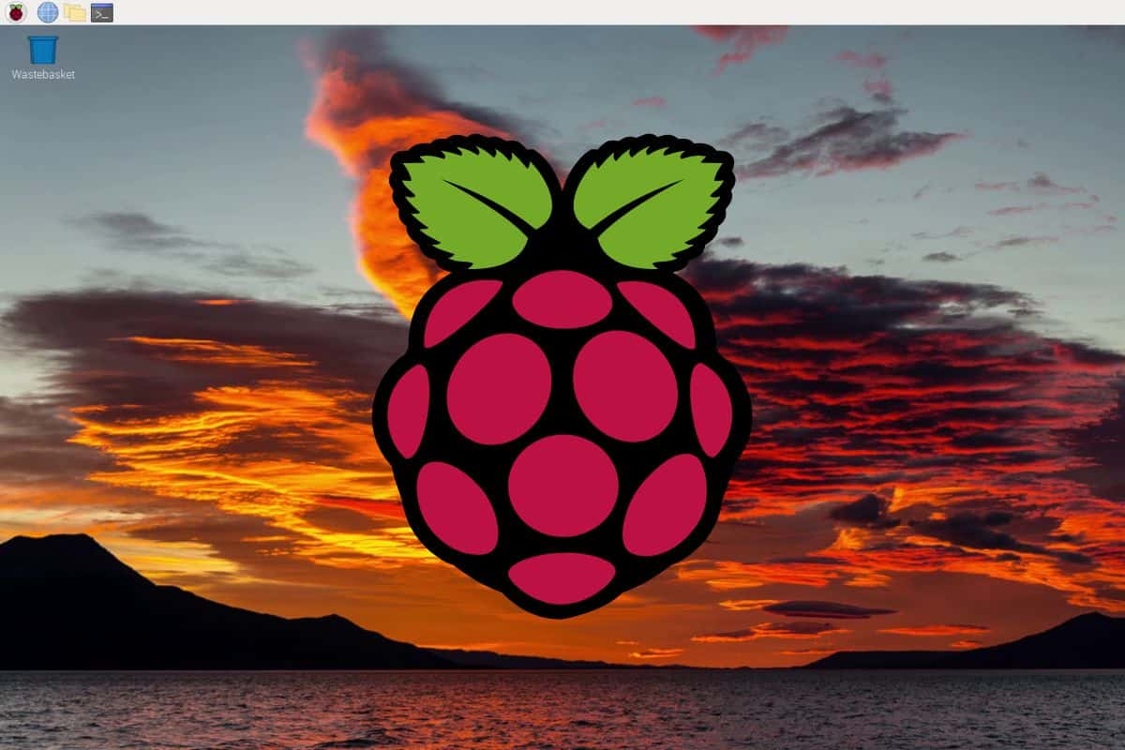

Fig 4.2.1 Raspberry Pi OS

4.2.2 Software Description for NumPy
NumPy, short for Numerical Python, is an open-source library in Python used for numerical computing. It provides iop powerful data structures, implemented in C and Fortran, that facilitate efficient manipulation and computation of large arrays and matrices. NumPy is widely used in scientific computing, data analysis, machine learning, and other domains where numerical operations are prevalent. In this software description, we will delve into the features, functionality, usage, and significance of NumPy in the Python ecosystem.

NumPy:
NumPy was created by Travis Oliphant in 2005 as an extension of Numeric and Numerary libraries, with the aim of providing a more efficient and flexible array computing library for Python. It has since become a fundamental building block for numerous scientific and computational applications due to its performance, ease of use, and extensive functionality.
Multidimensional Arrays: NumPy provides a powerful array object called ndarray (N- dimensional array), which allows for efficient storage and manipulation of arrays with arbitrary dimensions. This enables users to perform vectorized operations on arrays, avoiding the need for explicit looping over elements.
Mathematical Functions: NumPy includes a wide range of mathematical functions for performing operations such as arithmetic, trigonometry, logarithms, exponentials, and more. These functions are optimized for performance and can operate efficiently on large arrays.
Algebra Operations: NumPy provides a rich set of functions for linear algebra operations, including matrix multiplication, matrix decomposition (e.g., Singular Value Decomposition, LU decomposition), eigenvalue computation, and solving linear systems of equations.
Random Number Generation: NumPy offers facilities for generating random numbers and random samples from various probability distributions. These functions are useful for tasks such as simulation, modeling, and statistical analysis.
Broadcasting: NumPy's broadcasting feature allows arrays with different shapes to be combined in arithmetic operations, making it easy to perform element-wise operations on arrays of different sizes.
Integration with Other Libraries: NumPy seamlessly integrates with other scientific computing libraries in Python, such as SciPy, Matplotlib, and Pandas.

Installation and Setup:
NumPy can be easily installed using package managers like pip or conda. For example, to install NumPy using pip, you can run the following command in your terminal or command prompt:
pip install numpy
Alternatively, if you're using conda as your package manager, you can install NumPy using:
``` conda install numpy
Once installed, you can import NumPy in your Python scripts or interactive sessions using the following import statement:
python import numpy as np
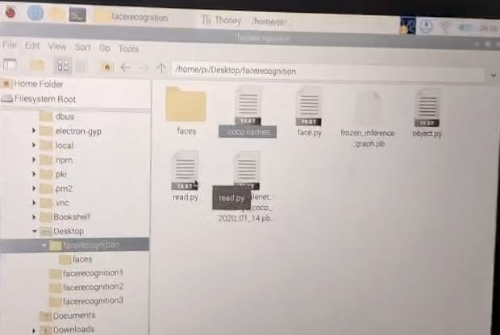
This convention of importing NumPy as np is widely followed in the Python community and is recommended for consistency.
Fig 4.2.2 Implementation Scripts

4.2.3 Software Description of OpenCV

OpenCV (Open Source Computer Vision Library) is a powerful open-source software library used for computer vision and machine learning applications, originally developed by Intel Corporation and now actively maintained by a global community of developers. It offers a rich collection of optimized algorithms and tools for image and video processing, feature extraction, object detection and tracking, facial recognition, machine learning, and augmented reality. Designed for efficiency and real-time performance, OpenCV supports multiple programming languages such as C++, Python, and Java, and runs across various platforms including Windows, Linux, Android, and iOS. Its modular architecture, extensive documentation, and strong community support make it a widely adopted framework in academic research, industrial automation, robotics, healthcare, surveillance.

Introduction to OpenCV:
OpenCV was first released in 1999 by Gary Bradsky as an open-source project aimed at advancing the field of computer vision research and development. Since then, it has grown into one of the most widely used libraries in the computer vision community, with contributions from thousands of developers worldwide. OpenCV is written in C++ and provides bindings for various programming languages, including Python, Java, and MATLAB, making it accessible to a broad audience of developers and researchers.
- Image and Video Processing: OpenCV provides a wide range of algorithms for processing images and videos, including image filtering, transformation, morphological operations, and color space conversion. Developers can perform tasks such as image enhancement, denoising, edge detection, and feature extraction using built-in functions and methods.
- Object Detection and Tracking: OpenCV includes algorithms for object detection and tracking, such as Haar cascades, HOG (Histogram of Oriented Gradients), and deep learning-based methods like SSD (Single Shot MultiBox Detector). These algorithms enable applications such as face detection, pedestrian detection, vehicle tracking, and gesture recognition.
- Feature Extraction and Matching: OpenCV provides algorithms for extracting and matching features in images, such as keypoints, descriptors, and feature detectors.
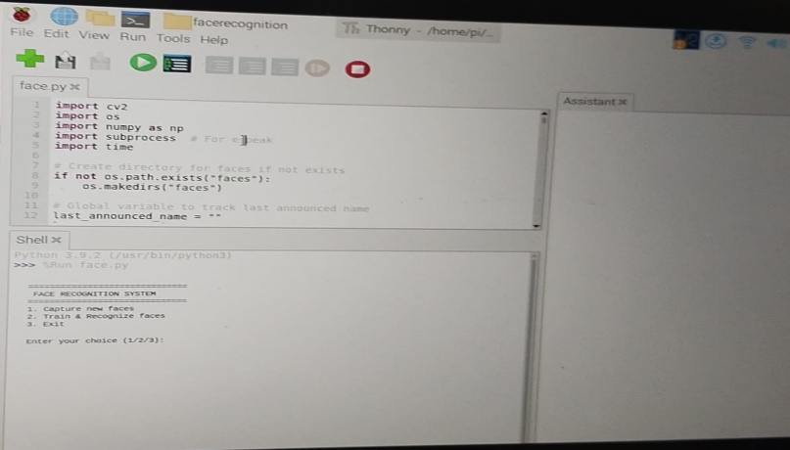
These algorithms are used in tasks such as image stitching, panorama creation, object recognition, and image registration. Machine Learning: OpenCV integrates with popular machine learning libraries such as scikit learn and TensorFlow, allowing developers to train and deploy machine learning models for tasks such as classification, regression, clustering, and dimensionality reduction. OpenCV also includes its own machine learning module with algorithms for support vector machines (SVM), k-nearest neighbors (KNN), decision trees, and more.
Fig 4.2.3 Implementation of Face recognition

B. Architecture of OpenCV:
  - Core Module: The core module provides basic data structures and functions for working with images, matrices, arrays, and other data types. It includes functions for image I/O, pixel manipulation, matrix operations, and memory management.
  - Image processing Module: The imgproc module contains algorithms for image processing and manipulation, such as filtering, resizing, rotation, warping, and thresholding. It includes functions for edge detection, contour detection, histogram equalization, and morphology operations.
  - Object detection Module: The object detection module includes algorithms for object detection and recognition, such as Haar cascades, HOG descriptors, and deep learning-based detectors. It provides functions for training and using object detection models on custom datasets.
  - Video Module: The video module provides algorithms for video processing and analysis, such as optical flow, motion estimation, background subtraction, and video stabilization. It includes functions for accessing video streams from cameras and files, as well as manipulating video frames.
  - Machine Learning Module: The machine learning module includes algorithms for machine learning tasks such as classification, regression, clustering, and dimensionality reduction. It provides functions for training and evaluating machine learning models using popular algorithms and techniques.

Software Description: SSD MobileNet Trained on COCO Dataset

SSD MobileNet (Single Shot Multibox Detector with MobileNet) is a highly efficient and accurate object detection model that integrates the lightweight MobileNet architecture with the fast and robust Single Shot Multi box Detector framework to enable real-time object detection on resource-constrained devices. Trained on the COCO dataset, which contains richly annotated images across 91 object categories, SSD MobileNet can detect multiple objects in a single forward pass with a strong balance between speed and precision. Its architecture uses depth wise separable convolutions to reduce computational complexity, while SSD enables multi scale feature maps for detecting objects of varying sizes. Owing to its fast inference, low memory footprint, and reliable accuracy, SSD MobileNet is widely used in real world applications such as surveillance systems, autonomous vehicles, robotics, mobile vision apps, and embedded AI solutions.

Step 1: Introduction to Object Detection:
Object detection is a fundamental task in computer vision that involves identifying and localizing objects within an image or video frame. Traditional object detection approaches typically involve multiple stages, such as region proposal generation, feature extraction, and object classification.

Step 2 : SSD MobileNet Architecture:
- MobileNet: MobileNet is a lightweight convolutional neural network architecture designed for mobile and embedded devices. It consists of depthwise separable convolutions, which reduce the number of parameters and computational complexity while preserving accuracy. MobileNet achieves a good balance between model size, speed, and accuracy, making it well-suited for deployment on resource- constrained platforms.
- SSD (Single Shot Multibox Detector): SSD is an efficient object detection framework that performs detection in a single pass through the network. Instead of relying on region proposal generation techniques like R-CNN, SSD uses a set of default bounding boxes (called priors) at multiple scales and aspect ratios to predict object bounding boxes and class probabilities directly from feature maps at different layers of the network. This enables faster and more accurate detection of objects in images and videos.

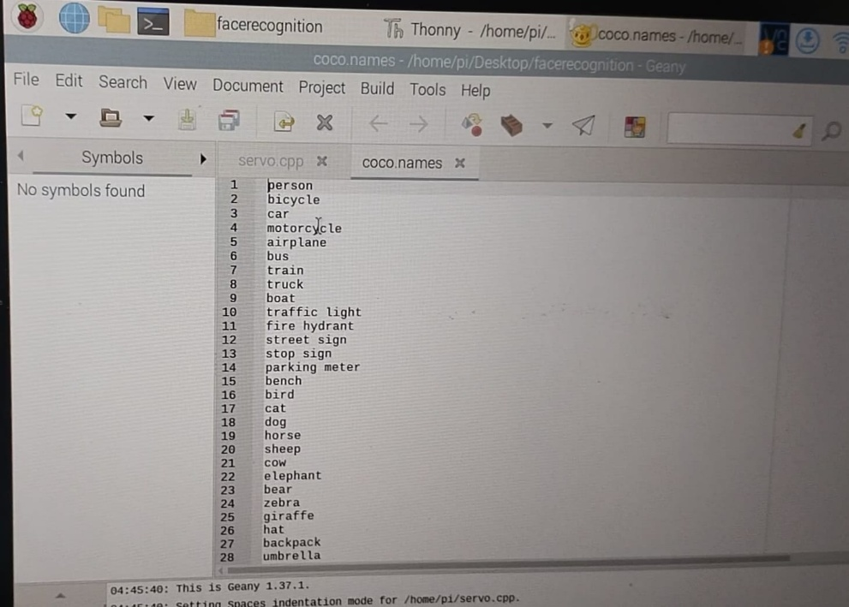
Step 3: Training Process on COCO Dataset:

Fig 4.2.4 COCO Data Sets
  - Data Preparation: The COCO dataset is divided into training, validation, and testing sets. Each image is annotated with bounding boxes and class labels corresponding to the objects present in the image.

  - Model Initialization: The SSD MobileNet model is initialized with pre-trained weights on a large-scale image classification dataset such as ImageNet. This helps speed up the training process and improves the model's ability to extract meaningful features from input images.
  - Fine-tuning: The pre trained SSD MobileNet model is fine tuned on the COCO dataset using gradient descent optimization techniques. During fine tuning, the model learns to adjust its parameters to minimize the difference between predicted bounding boxes and ground truth annotations for objects in the training images.
  - Evaluation: The performance of the trained SSD MobileNet model is evaluated on the validation set using standard metrics such as mean Average Precision (mAP)
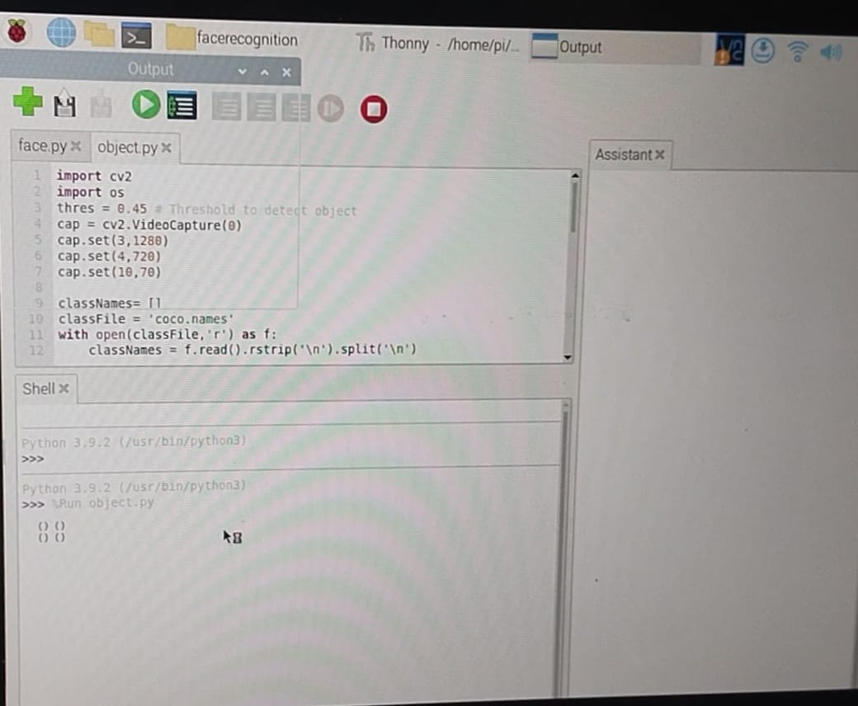
  - Hyperparameter Tuning: The training process involves tuning hyperparameters such as learning rate, batch size, and regularization strength to optimize the performance of the model on the validation set.

Fig 4.2.5 Implementation of Object Detection

CHAPTER 5
RESULT AND ANALYSIS
The AI-powered eye system developed using Raspberry Pi 4 successfully demonstrates how artificial intelligence can be used to support visually challenged individuals in their daily life. The project integrates hardware such as the Raspberry Pi 4, Pi Camera, speakers, and a microphone with software components including OpenCV, MobileNet SSD, Tesseract OCR, and a text-to- speech engine. Together, these components work to capture the surrounding environment, process visual information, and convert it into meaningful audio feedback for the user. The system functions as an artificial visual assistant that identifies objects, reads printed text aloud, and responds to simple voice commands. Through multiple tests, the device performed consistently and provided the necessary information to the user in real time, proving that an affordable and compact AI- based solution can effectively aid visually impaired people.
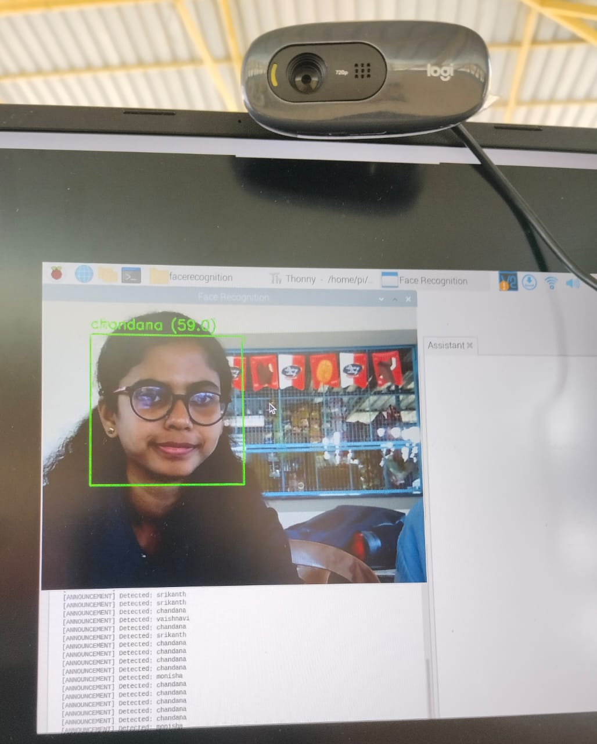
Fig.5.1 Face Recognition

The object detection module of the system forms the core functionality, enabling the device to recognize and announce objects present in front of the user. Using the lightweight MobileNet SSD model and OpenCV’s deep learning framework, the system is able to detect everyday objects such as people, chairs, bags, cars, doors, and other commonly encountered items.

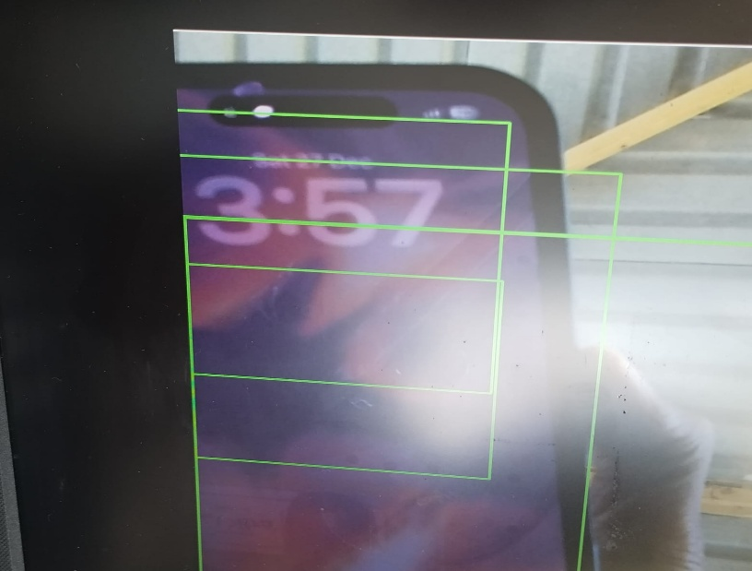
Fig 5.2 Object Detection

The device continuously analyses the camera feed and provides real-time audio feedback, saying phrases like “person ahead,” “vehicle on right,” or “chair in front.” This improves situational awareness for the user and helps them avoid obstacles. Even though Raspberry Pi is a low-cost board, it handles the detection tasks efficiently, showing that optimized AI models can be deployed on edge devices without needing expensive hardware.
Fig 5.3 Text Recognition
Another major part of the system is its ability to read printed text using Optical Character Recognition. Using Tesseract OCR, the device captures an image from the camera, extracts characters from the image, and converts the recognized text to speech using a voice output module. This feature is extremely beneficial for visually impaired users because it allows them to independently read items such as bus numbers, signboards, product labels, menus, books, receipts, and official documents. During testing, the OCR module worked well under natural lighting conditions and with clear printed text.

The system also incorporates voice control to make the device hands-free and easy to operate. Visually challenged users often prefer voice-based interfaces because they do not require physical buttons or on-screen menus. By using a basic voice recognition module, the device can understand simple commands like “read text,” “identify objects,” or “start detection.” This enhances user convenience and accessibility, ensuring that the device can be used without any technical difficulty. The lightweight design, along with power-bank support, makes it portable and suitable for wearing or carrying throughout the day. When combined with earbuds or a small speaker, users receive clear and private audio feedback, making the experience more comfortable and personalized.
While the overall performance of the system is strong, the analysis also reveals some limitations that can be addressed in future improvements. For example, the accuracy of object detection reduces in low-light or overly bright environments because the camera struggles to capture clear frames. Similarly, OCR performance declines when text is handwritten, blurred, or presented in unusual fonts. Processing multiple objects at once may cause slight delays in speech output due to the computational load on the Raspberry Pi’s CPU. These limitations are common in edge-based AI devices, especially when using lightweight models.

CHAPTER 6
ADVANTAGES AND APPLICATIONS

6.1 ADVANTAGES

Real Time Feedback : The system provides instant audio descriptions of the surroundings, allowing users to react quickly. This real-time support is essential for safe navigation. It reduces hesitation and builds confidence during movement.

Multi Functional System : It combines object detection, OCR, and face recognition in a single device. This eliminates the need for multiple tools and simplifies the user experience. The integration also ensures that the user receives complete environmental awareness.

Portable and Wearable : The device is lightweight and easy to carry throughout the day. Its compact design makes it suitable for daily use without causing discomfort. This portability ensures that users can rely on it in any environment.

Cost-Effective Technology : Using Raspberry Pi and open source AI models keeps the overall cost low. This makes the device more accessible to visually impaired individuals who may not afford commercial solutions. It also encourages educational and research use.

Local Processing for Privacy : All image processing happens directly on the Raspberry Pi. This prevents sensitive visual data from being uploaded to the internet. As a result, the user’s personal surroundings remain private and secure.

Easy to Upgrade : The system can be improved by adding new sensors or updating AI models. This flexibility allows the device to evolve with technological advancements.

6.2 APPLICATIONS

Navigation Assistance : The device helps visually impaired users move safely by identifying obstacles and guiding them through audio feedback. It is especially useful in unfamiliar environments.

Reading Printed Text : With OCR, the system can read signboards, labels, menus, and documents aloud. This makes everyday tasks like shopping or traveling much easier.

Face Recognition for Social Interaction : The device can identify familiar faces and notify the user. This helps users recognize friends, family, or colleagues in social situations.

Indoor Guidance : It can detect furniture, doors, and pathways inside homes or buildings. This reduces the risk of collisions and improves indoor mobility.

Outdoor Environment Awareness : The system can identify vehicles, traffic signs, and street objects. This supports safer outdoor navigation and enhances situational awareness.

Educational Support : Visually impaired students can use the device to read books, classroom boards, and printed materials. It supports independent learning and academic participation.

6.3 FUTURE SCOPE

Integration with GPS Navigation : Future versions can include GPS to provide turn-by-turn navigation. This would make outdoor travel even more reliable and user-friendly.

Voice Command Control : Adding voice-based interaction would allow users to control modes and features hands- free. This improves accessibility and ease of use.

Advanced AI Models : More powerful AI models can be added for higher accuracy in object detection and face recognition. This will make the system smarter and more reliable.

Cloud Connectivity : Cloud support can enable real-time updates, larger databases, and improved processing. This would expand the system’s capabilities beyond local hardware limits.

Multilingual Audio Output : The device can be upgraded to support multiple languages. This makes it useful for users from different regions and backgrounds.

Gesture and Emotion Recognition : Future versions could detect human gestures or emotions. This would help users understand social cues more effectively.

Integration with Smart Glasses : The system can be embedded into lightweight smart glasses for a more natural and wearable experience. This improves comfort and usability.

Enhanced Battery Technology : Long lasting batteries or solar-powered options can be added. This would increase usage time and reduce the need for frequent charging.

Real Time Crowd Analysis : Future upgrades could analyse crowd density and movement. This helps users avoid crowded or unsafe areas.

CONCLUSION

The development of this AI Powered assistive device demonstrates how modern technology can meaningfully support visually impaired individuals in their daily lives. By combining image processing, object detection, OCR, and face recognition into a single portable system, the project successfully bridges the gap between visual information and accessible audio feedback. The integration of Raspberry Pi 4 and lightweight AI models shows that powerful assistive solutions can be built using affordable and compact hardware. This project also highlights how engineering and social responsibility can come together to create technology that genuinely improves human experiences.
Through real time image analysis and continuous audio output, the device enhances the user’s awareness of their surroundings and promotes safer, more confident navigation. The system’s ability to detect objects, read text, and recognize familiar faces makes it a versatile tool that can be used in homes, workplaces, and public environments. Its design focuses on practicality, privacy, and ease of use, ensuring that visually impaired users can rely on it without requiring technical expertise. The project also demonstrates how AI can be adapted to real-world conditions, making it not just a theoretical concept but a practical, functioning solution.
Overall, this project highlights the potential of AI driven assistive technologies to improve independence and quality of life for visually challenged individuals. With further advancements such as GPS integration, improved AI models, and enhanced battery performance, the device can evolve into an even more powerful companion. The project not only demonstrates technical innovation but also reflects a strong commitment to social impact and inclusive design. As technology continues to advance, solutions like this will play an increasingly important role in creating a more accessible and supportive world for everyone. This work also opens the door for future researchers and developers to build even more advanced assistive tools, ensuring that innovation continues to move toward inclusivity and empowerment.

REFERENCE

[1] A. Lavric, C. Beguni, E. Zadobrischi. “A comprehensive survey on emerging assistive technologies for visually impaired persons: Lighting the path with visible light communications and artificial intelligence innovations,”
[2] P. N. Shinde, V. Honmane, V. Jadhav, S. Nigade, and D. Suryawanshi. “Assistive vision technologies for the visually impaired: A comprehensive literature survey,” ITSI Transactions on Electrical and Electronics Engineering.
[3]. Han, M. Beheshti, B. Jones, T. E. Hudson, W. H. Seiple, and J.-R. Rizzo, “Wearables for persons with blindness and low vision: Form factor matters,” Assistive Technology, 2023.
[4]. F. Yao, W. Zhou, and H. Hu, “A review of vision-based assistive systems for visually impaired people: Technologies, applications, and future directions,” 2025.
[5]. L. Manirajee, S. Q. H. Shariff, and S. M. M. Rashid, “Assistive technology for visually impaired individuals: A systematic literature review (SLR),” Int. J. Acad.
[6]. AI Eyes for the Visually Impaired: A Vision for a More Inclusive Future. A preprint proposing AI-enabled goggles/headsets with real-time visual understanding to help visually impaired users “see.”
[7]. R. Kumar and S. Patel, “Visioneer: AI-guided navigation for the visually impaired using YOLO, OpenCV and text-to-speech,” International Journal for Research in Applied Science & Engineering Technology (IJRASET), vol. 10, no. 5, 2022.
[8] A. Sharma, P. Mehta, and R. Verma, “Smart obstacle detection system: An AI-IoT assistive system for the visually impaired,” IJRASET, vol. 11, no. 2, 2023.
[9] S. Zhang, R. Benenson, and B. Schiele, “Single Shot Multibox Detector,” European Conference on Computer Vision (ECCV), pp. 21–37, 2016.
[10] R. Smith, “An overview of the Tesseract OCR engine,” Proceedings of the International Conference on Document Analysis and Recognition (ICDAR), pp. 629–633, 2007.

APPENDIX

Face Recognition System:
import cv2
import os
import numpy as np
import subprocess # For espeak
import time
# Create directory for faces if not exists
if not os.path.exists("faces"):
os.makedirs("faces")
# Global variable to track last announced name
last_announced_name = ""
last_announce_time = 0
ANNOUNCE_COOLDOWN = 5 # seconds between announcements for the same person
# Function to announce name using espeak
def announce_name(name):
global last_announced_name, last_announce_time
current_time = time.time()
# Only announce if it's a different name or enough time has passed
if (name != last_announced_name or
(name == last_announced_name and current_time - last_announce_time > ANNOUNCE_COOLDOWN)):
try:
# Use espeak to announce the name
subprocess.run(['espeak', '-s', '150', name],
stdout=subprocess.DEVNULL,
stderr=subprocess.DEVNULL)
print(f"[ANNOUNCEMENT] Detected: {name}")
# Update tracking variables
last_announced_name = name
last_announce_time = current_time
except Exception as e:

print(f"[ERROR] Could not announce name: {e}")
# Step 1: Capture training images
def capture_faces():
person_name = input("Enter the name of the person: ").strip()
person_path = os.path.join("faces", person_name)
os.makedirs(person_path, exist_ok=True)
face_cascade = cv2.CascadeClassifier(cv2.data.haarcascades + "haarcascade_frontalface_default.xml")
cap = cv2.VideoCapture(0)
count = 0
print("\n[INFO] Capturing faces... Look at the camera. Press ESC to stop early.\n")
while True:
ret, frame = cap.read()
if not ret:
break
gray = cv2.cvtColor(frame, cv2.COLOR_BGR2GRAY)
faces = face_cascade.detectMultiScale(gray, 1.3, 5)
for (x, y, w, h) in faces:
count += 1
face = gray[y:y + h, x:x + w]
face = cv2.resize(face, (200, 200))
file_path = os.path.join(person_path, f"{count}.jpg")
cv2.imwrite(file_path, face)
cv2.rectangle(frame, (x, y), (x + w, y + h), (0, 255, 0), 2)
cv2.putText(frame, f"Images: {count}", (x, y - 10), cv2.FONT_HERSHEY_SIMPLEX, 0.8, (255, 255, 255), 2)
cv2.imshow("Capture Faces", frame)
if cv2.waitKey(1) & 0xFF == 27 or count >= 150:
break
cap.release()
cv2.destroyAllWindows()
print(f"[INFO] Captured {count} face images for '{person_name}'.\n")

# Step 2: Train and recognize faces
def recognize_faces():
global last_announced_name, last_announce_time
# Reset announcement tracking
last_announced_name = ""
last_announce_time = 0
train_dir = "faces/"
faces = []
labels = []
label_dict = {}
label_count = 0
# Load training images
for person_name in os.listdir(train_dir):
person_path = os.path.join(train_dir, person_name)
if not os.path.isdir(person_path):
continue
label_dict[label_count] = person_name
for image_name in os.listdir(person_path):
img_path = os.path.join(person_path, image_name)
img = cv2.imread(img_path, cv2.IMREAD_GRAYSCALE)
if img is not None:
img = cv2.resize(img, (200, 200))
faces.append(img)
labels.append(label_count)
label_count += 1
if len(faces) == 0:
print("[ERROR] No training images found. Please capture faces first.")
return
print(f"[INFO] Training model on {len(faces)} images of {len(label_dict)} people...")
recognizer = cv2.face.LBPHFaceRecognizer_create()
recognizer.train(faces, np.array(labels))
print("[INFO] Training complete. Starting real-time recognition...\n")
cap = cv2.VideoCapture(0)
face_cascade = cv2.CascadeClassifier(cv2.data.haarcascades +

"haarcascade_frontalface_default.xml")
while True:
ret, frame = cap.read()
if not ret:
break
gray = cv2.cvtColor(frame, cv2.COLOR_BGR2GRAY)
detected_faces = face_cascade.detectMultiScale(gray, 1.3, 5)
for (x, y, w, h) in detected_faces:
roi_gray = gray[y:y + h, x:x + w]
roi_gray = cv2.resize(roi_gray, (200, 200))
label, confidence = recognizer.predict(roi_gray)
if confidence < 80:
name = label_dict[label]
text = f"{name} ({round(confidence, 1)})"
color = (0, 255, 0)
# Announce the detected person's name
announce_name(name)
else:
name = "Unknown"
text = f"{name} ({round(confidence, 1)})"
color = (0, 0, 255)
cv2.putText(frame, text, (x, y - 10), cv2.FONT_HERSHEY_SIMPLEX, 0.8, color, 2)
cv2.rectangle(frame, (x, y), (x + w, y + h), color, 2)
cv2.imshow("Face Recognition", frame)
if cv2.waitKey(1) & 0xFF == 27: # ESC to exit
break
cap.release()
cv 2.destroyAllWindows()
# Main Menu
def main():
print("""
FACE RECOGNITION SYSTEM
1. Capture new faces
2. Train & Recognize faces
3. Exit

""")
choice = input("Enter your choice (1/2/3): ").strip()
if choice == "1":
capture_faces()
main()
elif choice == "2":
recognize_faces()
main()
elif choice == "3":
print("Exiting...")
exit()
else:
print("Invalid choice. Try again.\n")
main()
if _name_ == "_main_":
main()

Object Detection System:
import cv2
import os
thres = 0.45 # Threshold to detect object
cap = cv2.VideoCapture(0)
cap.set(3,1280)
cap.set(4,720)
cap.set(10,70)
classNames= []
classFile = 'coco.names'
with open(classFile,'r') as f:
classNames = f.read().rstrip('\n').split('\n')
configPath = 'ssd_mobilenet_v3_large_coco_2020_01_14.pbtxt'
weightsPath = 'frozen_inference_graph.pb'
net = cv2.dnn_DetectionModel(weightsPath,configPath)
net.setInputSize(320,320)
net.setInputScale(1.0/ 127.5)
net.setInputMean((127.5, 127.5, 127.5))
net.setInputSwapRB(True)
while True:
success,img = cap.read()
classIds, confs, bbox = net.detect(img,confThreshold=thres)
print(classIds,bbox)
if len(classIds) != 0:
for classId, confidence,box in zip(classIds.flatten(),confs.flatten(),bbox):
cv2.rectangle(img,box,color=(0,255,0),thickness=2)
if classId < 91 :
print (classNames[classId-1])
print('audio begin')
s = 'espeak "'+classNames[classId-1]+'"'
os.system(s)
cv2.imshow("Output",img)
cv2.waitKey(1)

Text Recognition System:
import time
import pytesseract
import os
import cv2
from threading import Thread
from PIL import Image

# Optional: Set path to tesseract executable (for Windows users)
# pytesseract.pytesseract.tesseract_cmd = r'C:\Program Files\Tesseract-OCR\tesseract.exe'

# Function to convert text to audio using espeak
def txt_audio(msg):
print('audio begin')
s = f'espeak "{msg}"'
os.system(s)

# Function to convert image to text and speak it
def img_txt(image):
content = pytesseract.image_to_string(image)
print('audio begin')
s = f'espeak "{content}"'
os.system(s)
print(content)

# Initialize webcam
cap = cv2.VideoCapture(0)
if not cap.isOpened():
print("Cannot open camera")
exit()

print("Showing camera preview for 5 seconds...")

start_time = time.time()
while True:
ret, frame = cap.read()
if not ret:
print("Failed to grab frame")
break

cv2.imshow('Camera Preview - Press Q to quit', frame)

# Exit after 5 seconds or if 'q' is pressed
if cv2.waitKey(1) & 0xFF == ord('q') or time.time() - start_time > 5:
break

# Final capture
ret, final_frame = cap.read()
cap.release()
cv2.destroyAllWindows()
if not ret:

print("Failed to capture final frame")
exit()

# Convert captured frame to PIL Image
image = Image.fromarray(cv2.cvtColor(final_frame, cv2.COLOR_BGR2RGB))

# Crop and resize
width, height = image.size
left = 6
top = height / 4
right = 174
bottom = 3 * height / 4

cropped_image = image.crop((left, top, right, bottom))
resized_image = cropped_image.resize((750, 400))

# Convert image to text and speak
img_txt(image)

